Lease Management  
**college name**: TIRUPPUR KUMARAN COLLEGE FOR WOMEN

**College code:** bru3j

**TEAM ID:** **NM2025TMID28405**

**TEAM MEMBERS:**

**Team LeaderName:** JANANI A

**Email:** [janujanani24032006@gmail.com](mailto:janujanani24032006@gmail.com)

**Team member1:** ASMA A

**Email:** [asmaabuthahir@gmail.com](mailto:asmaabuthahir@gmail.com)

**Team member:**JANAGANANDHINI M

**Email:** muruganmurugam992

**Team member:** SOWMYA T

**Email:**

**1.INTRODUCTION**

**1.1 Project Overview**

The Lease Management System is a Salesforce Based application designed to streaming the processes associated with leasing real estate properties. It handles tenant management, lease contracts, payments, and communication with automation features such as flows, approval processes, and email alerts.

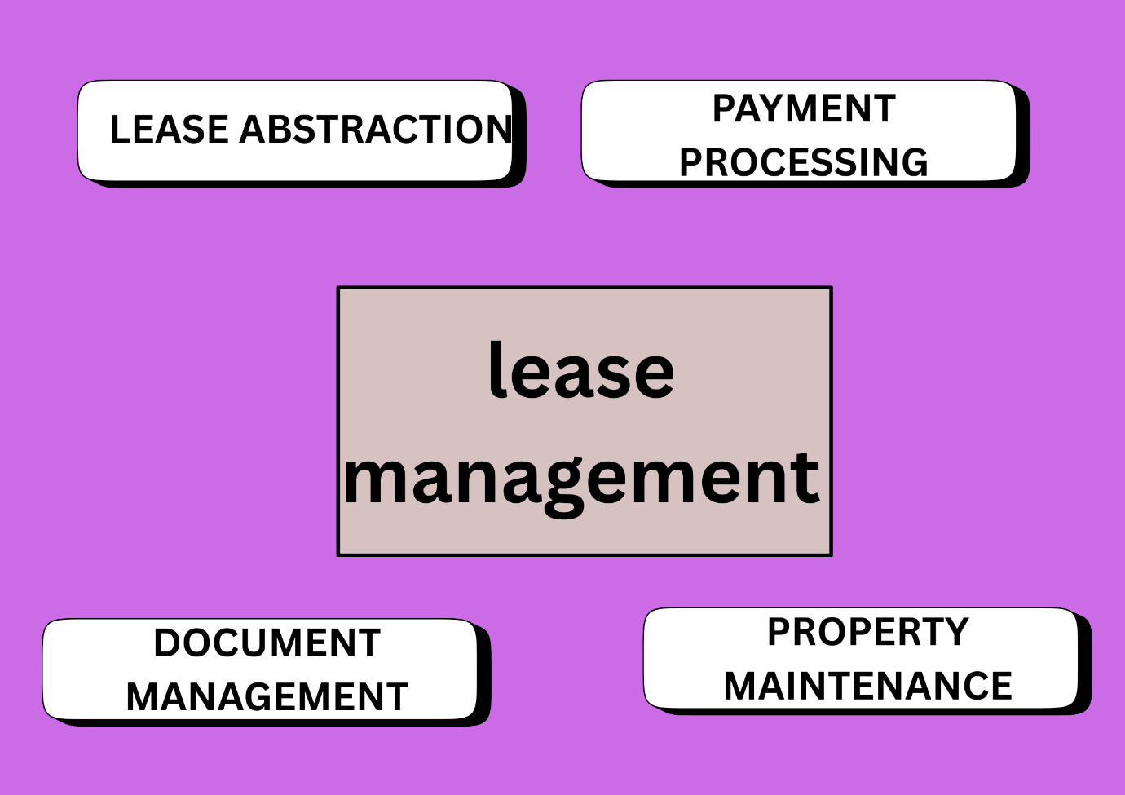

**1.2 Purpose**

The Main objective of the project is to enable organizations to efficiently manage properties, tenants, and lease related activities. It reduces manual intervention, improves accuracy, and ensures better compliance and communication.

**DEVELOPMENT PHASE**

**Creating developer Account:**

By using URL-<https://developer.salesforce.com/signup>

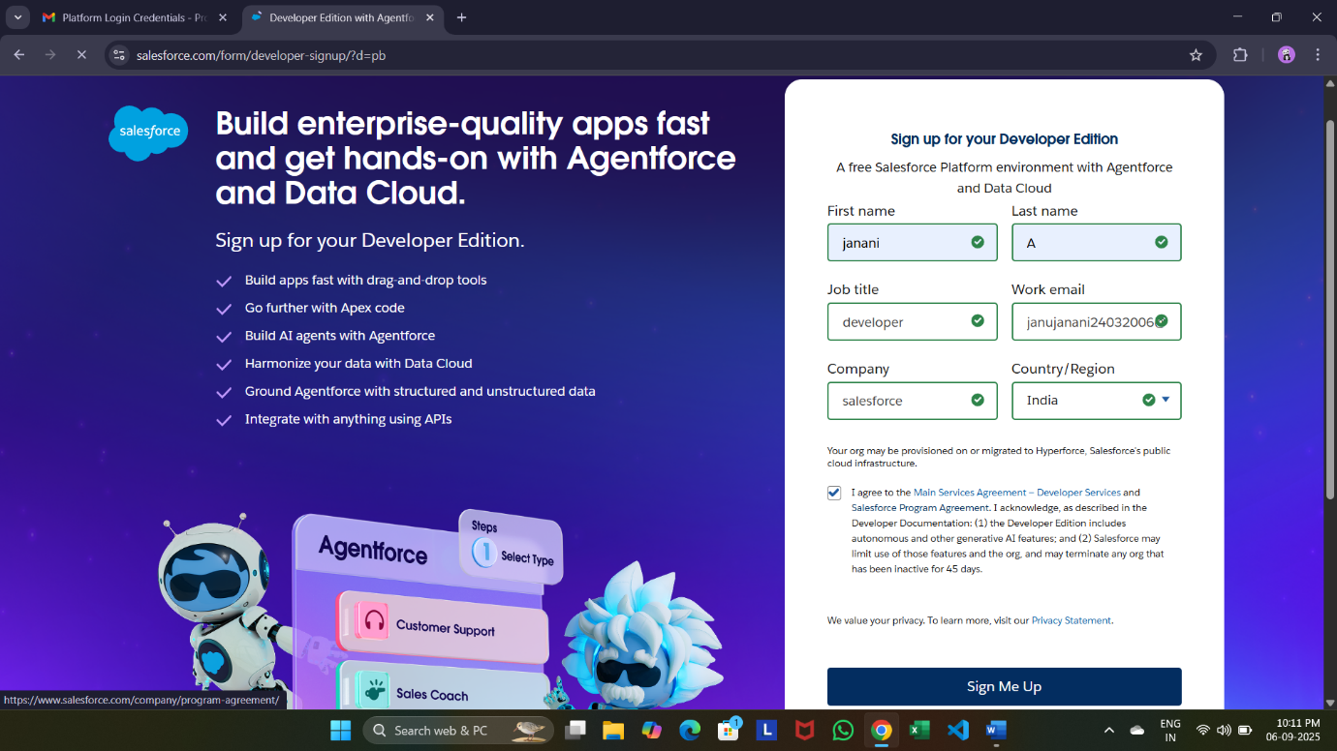

**Create objects:** property, Tenant, Lease, Payment

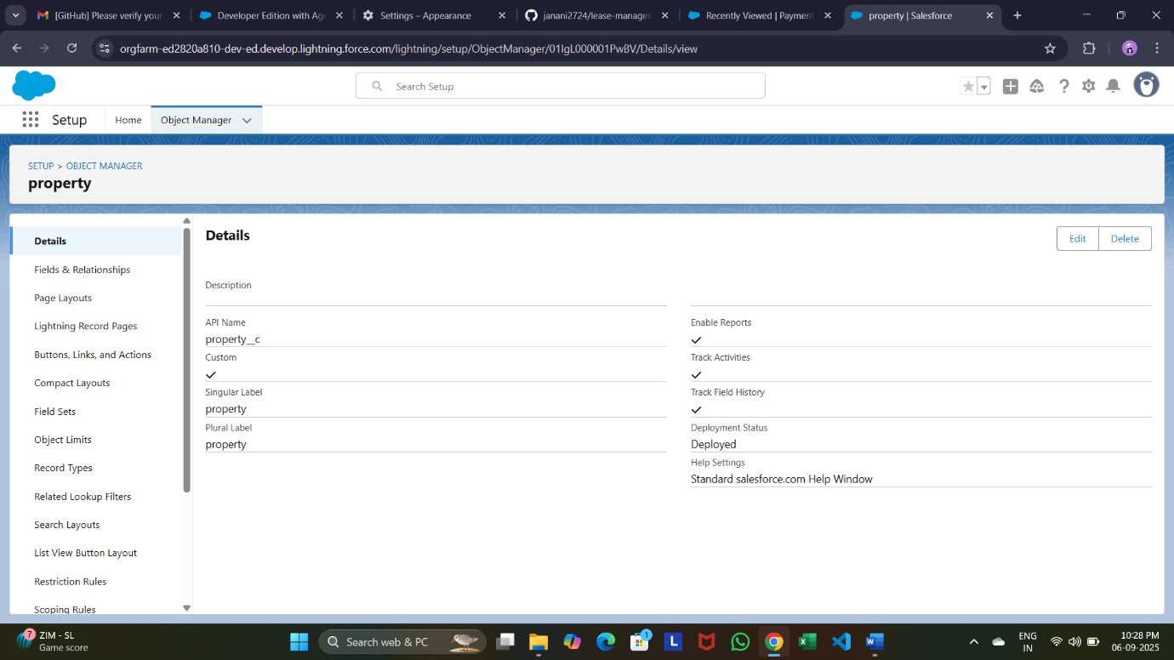

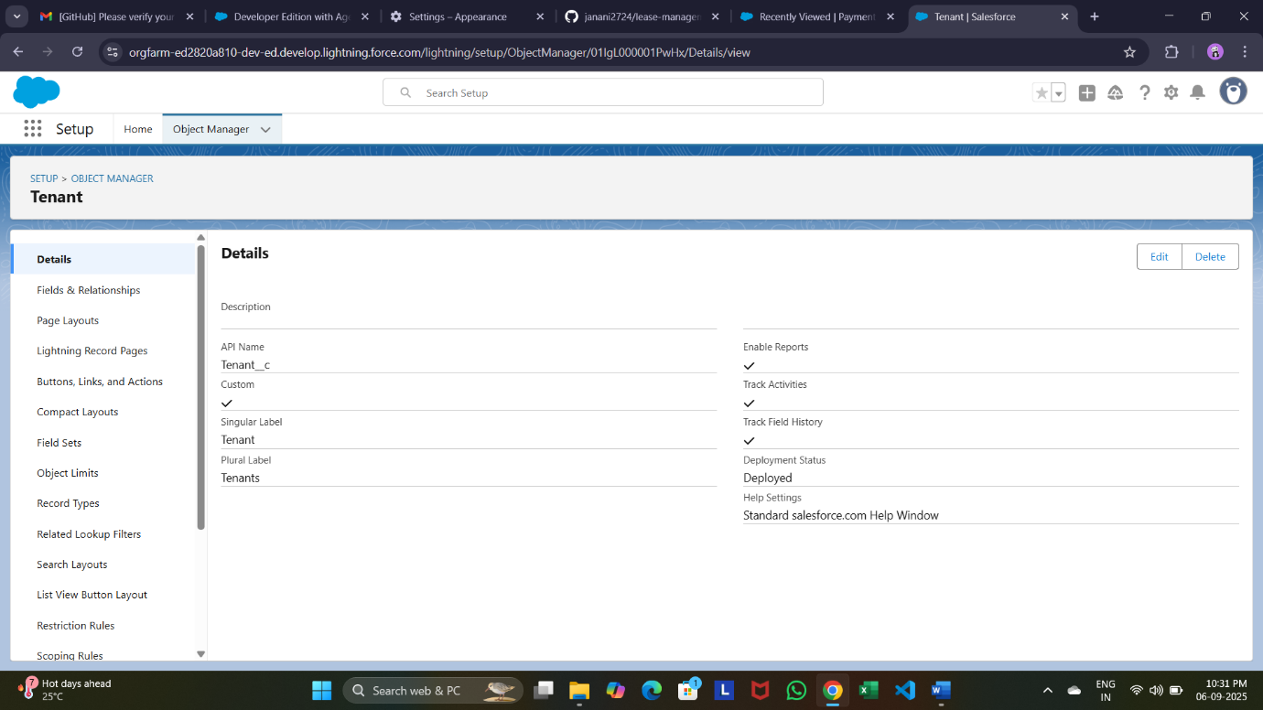

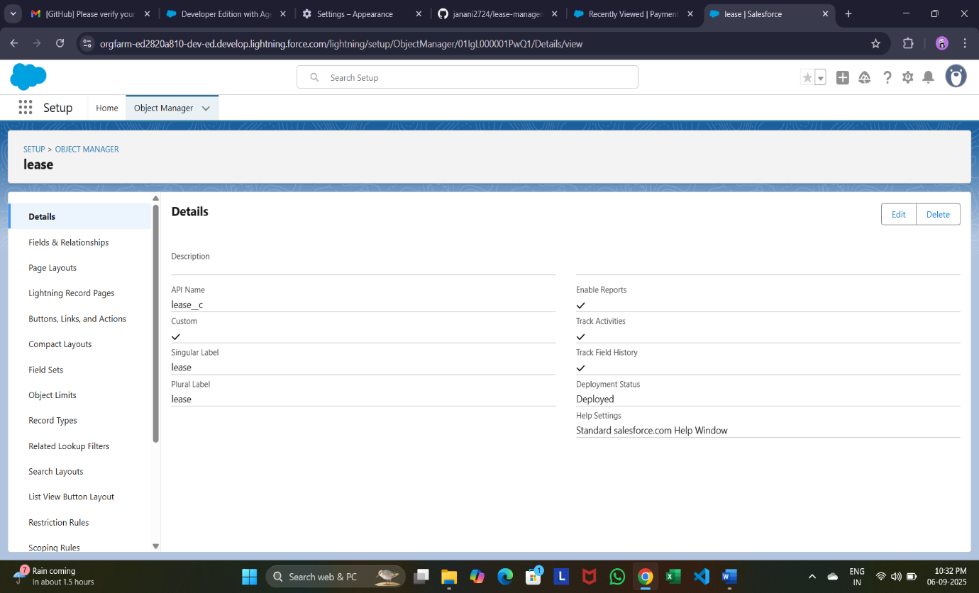

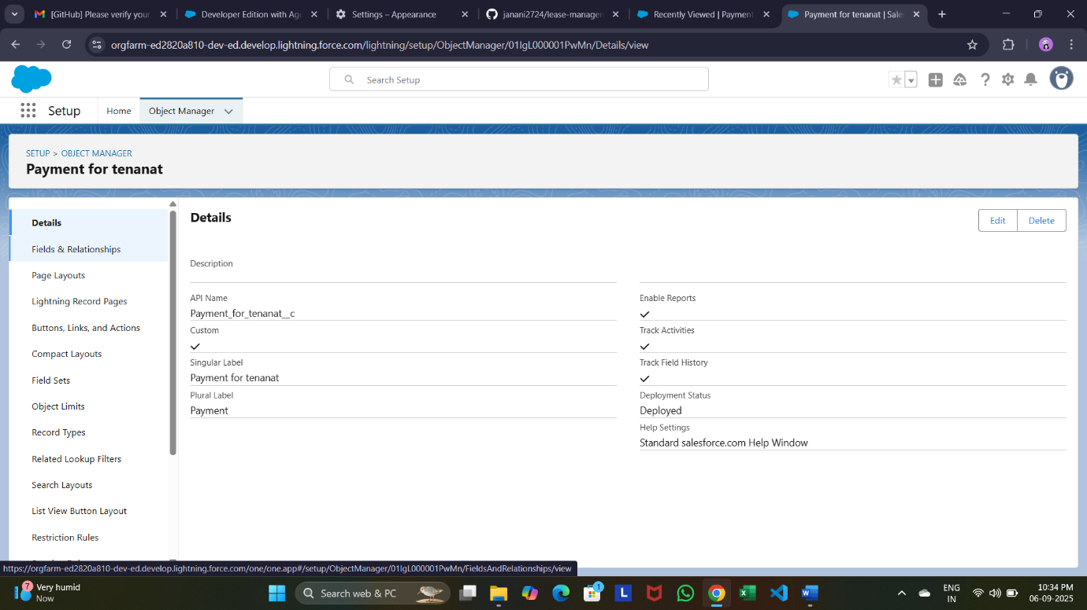

* Configured fields and relationships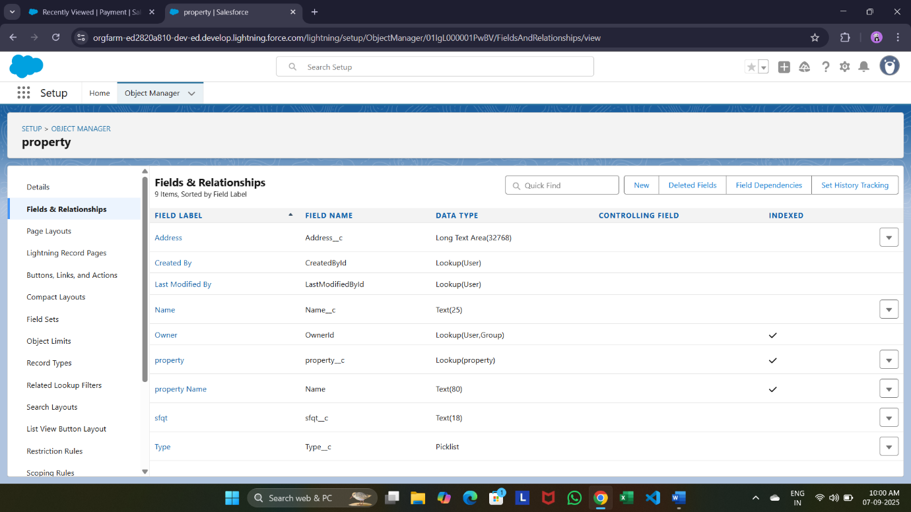

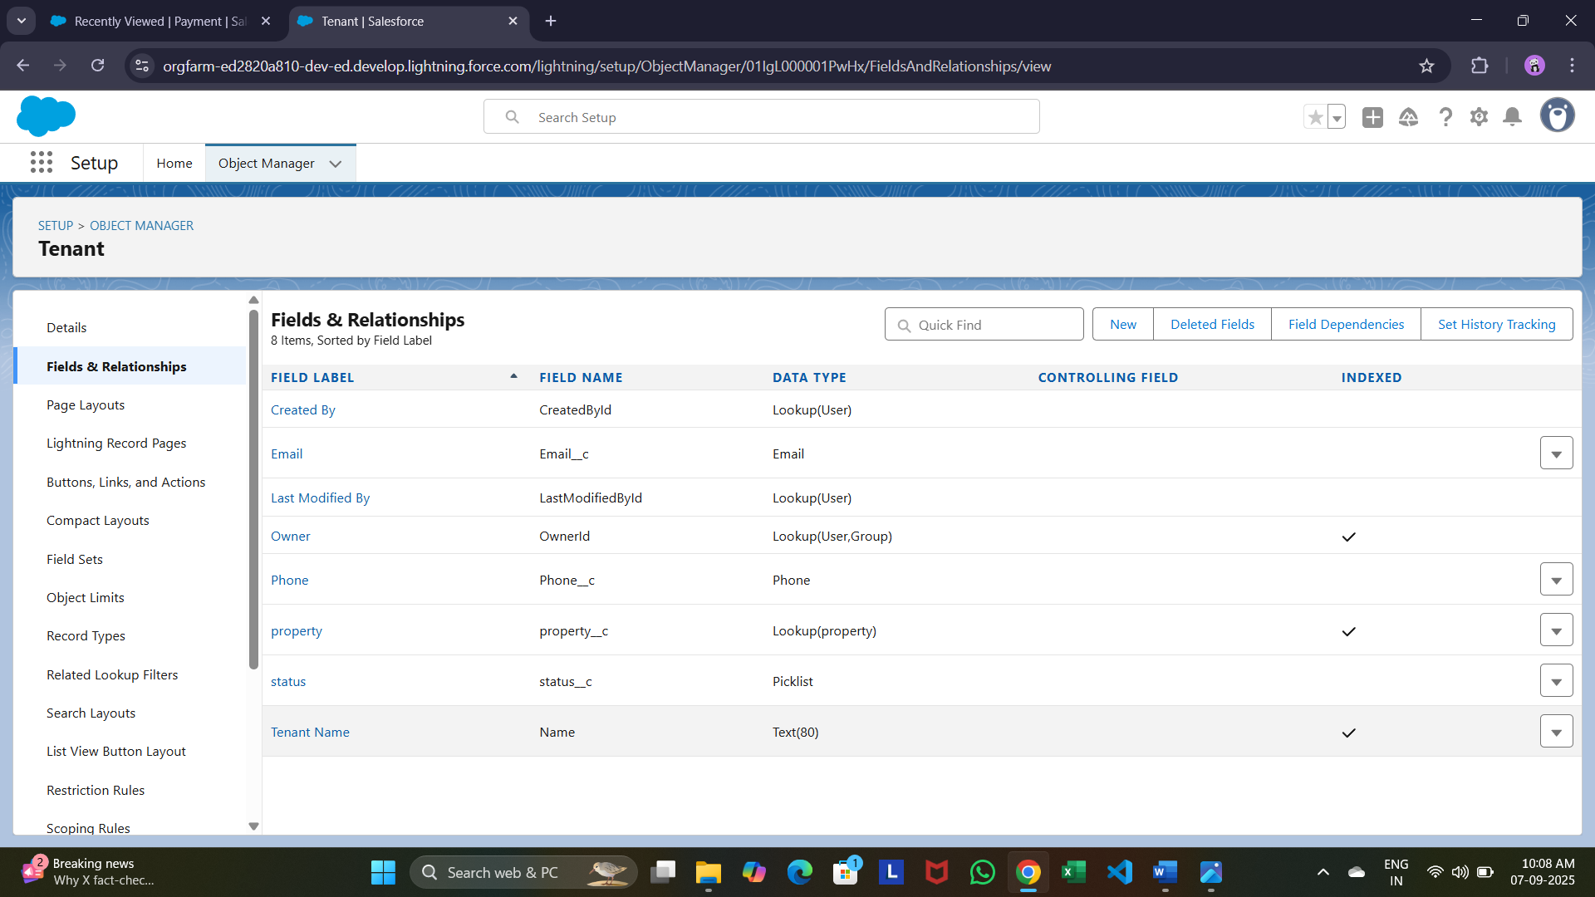

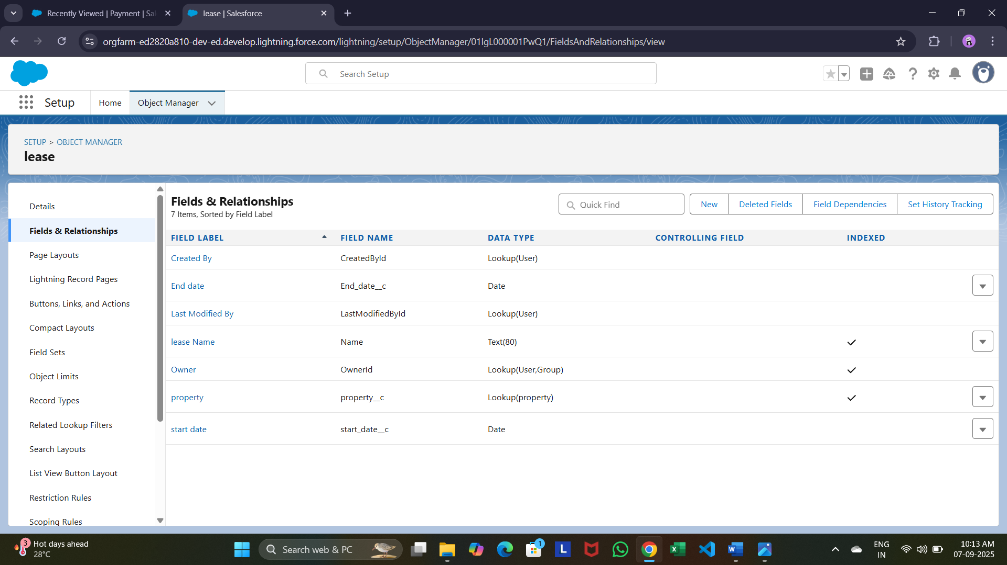

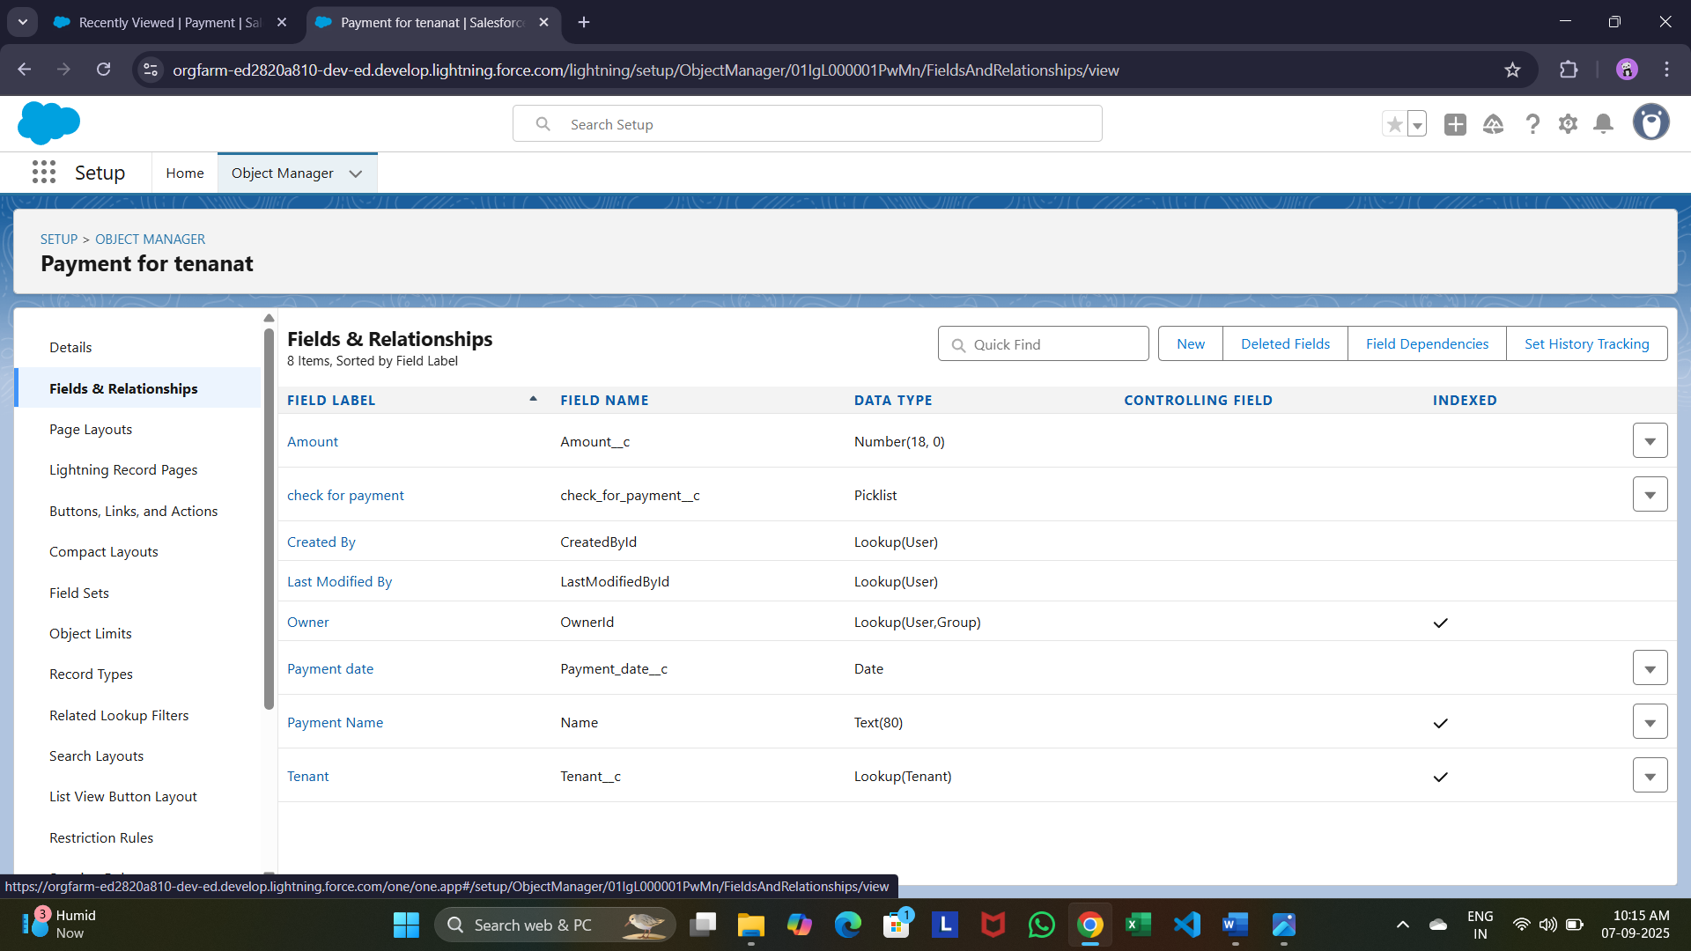

* **Developed Lightning App with relevant tabs**
* 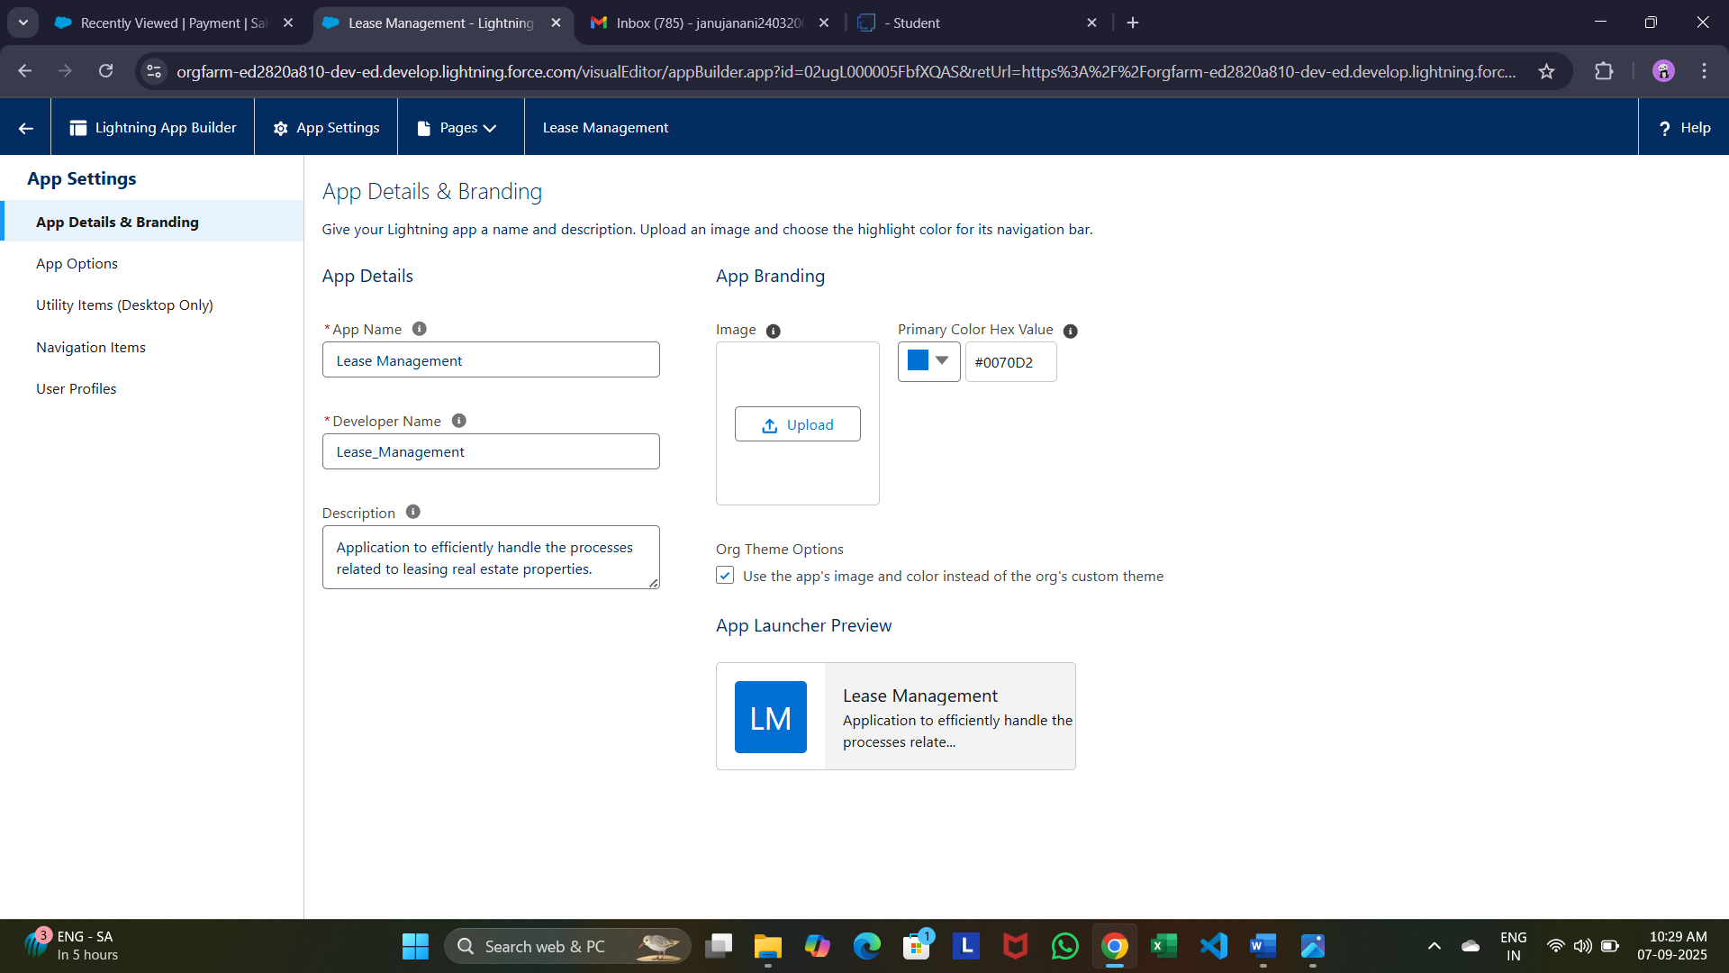

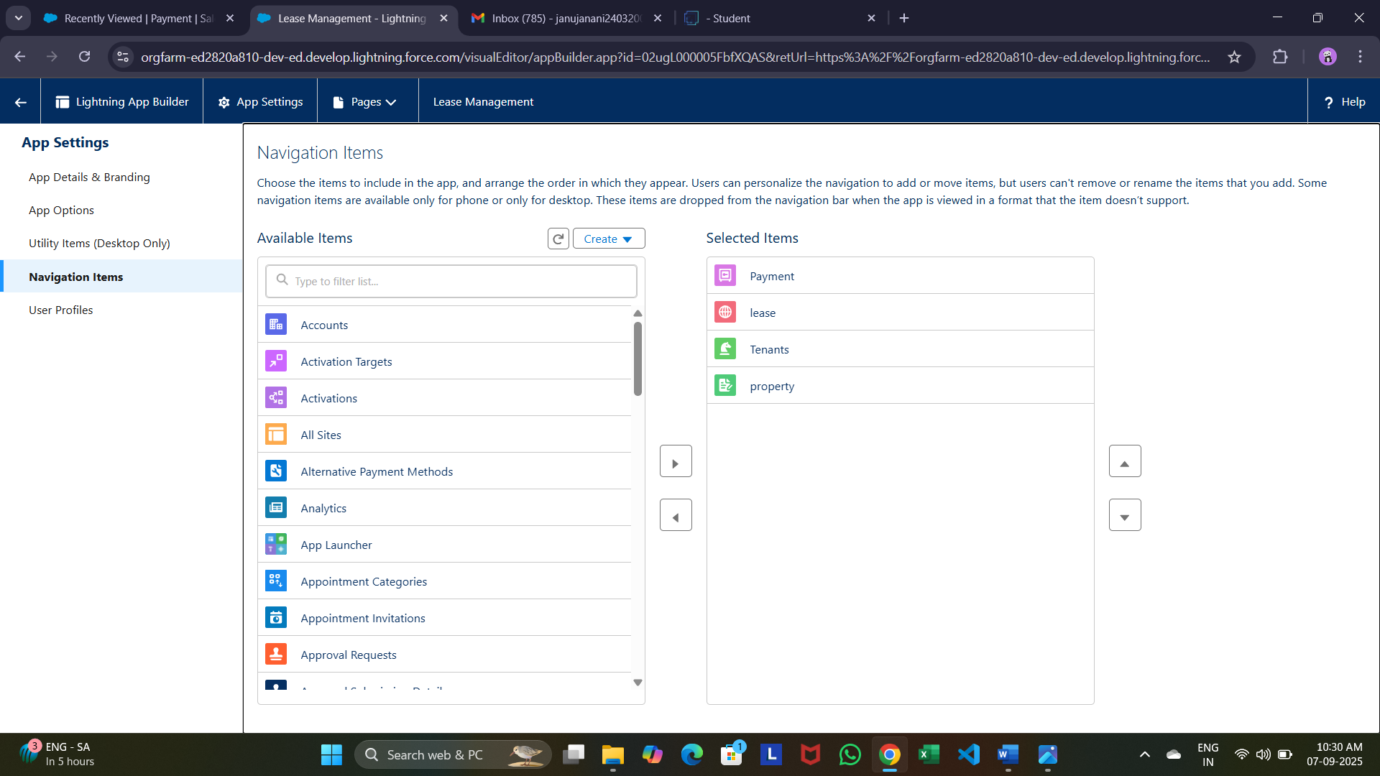

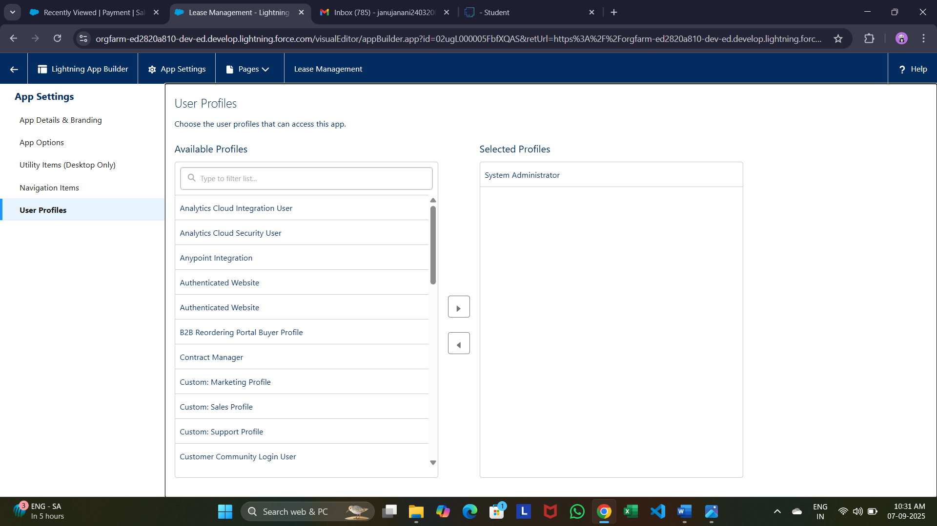

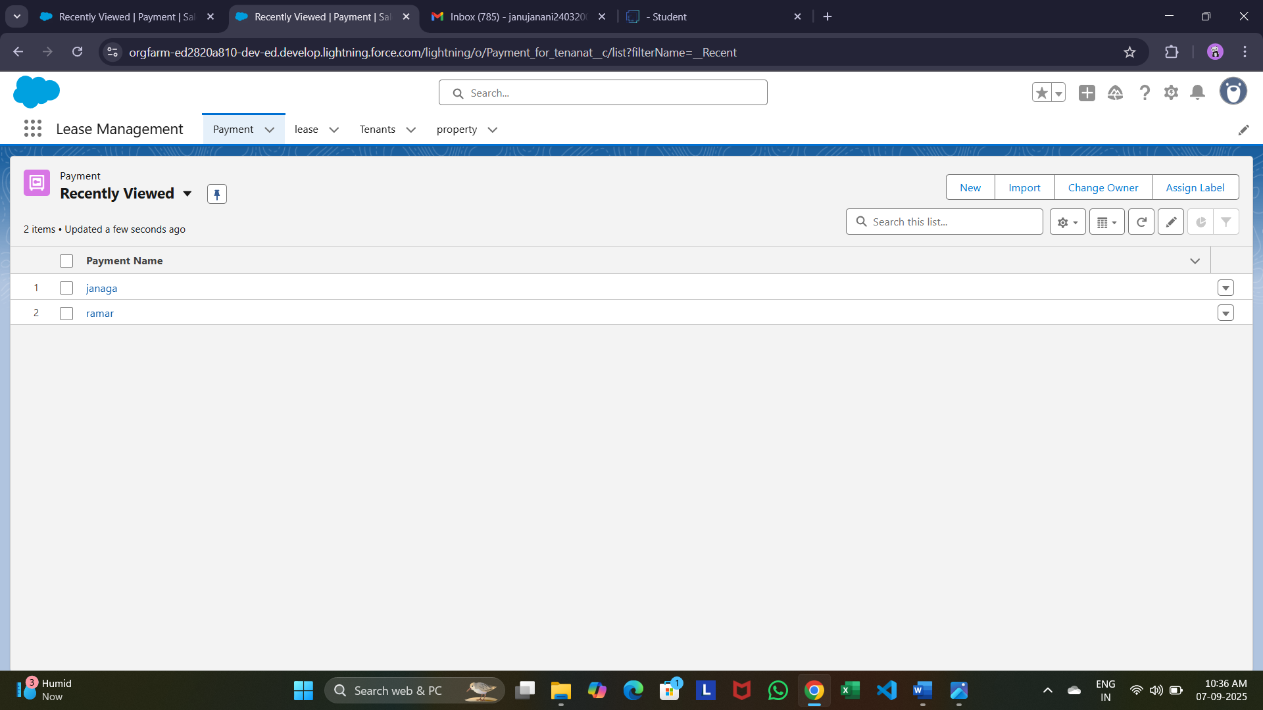

* **To create validation rule to lease Object**

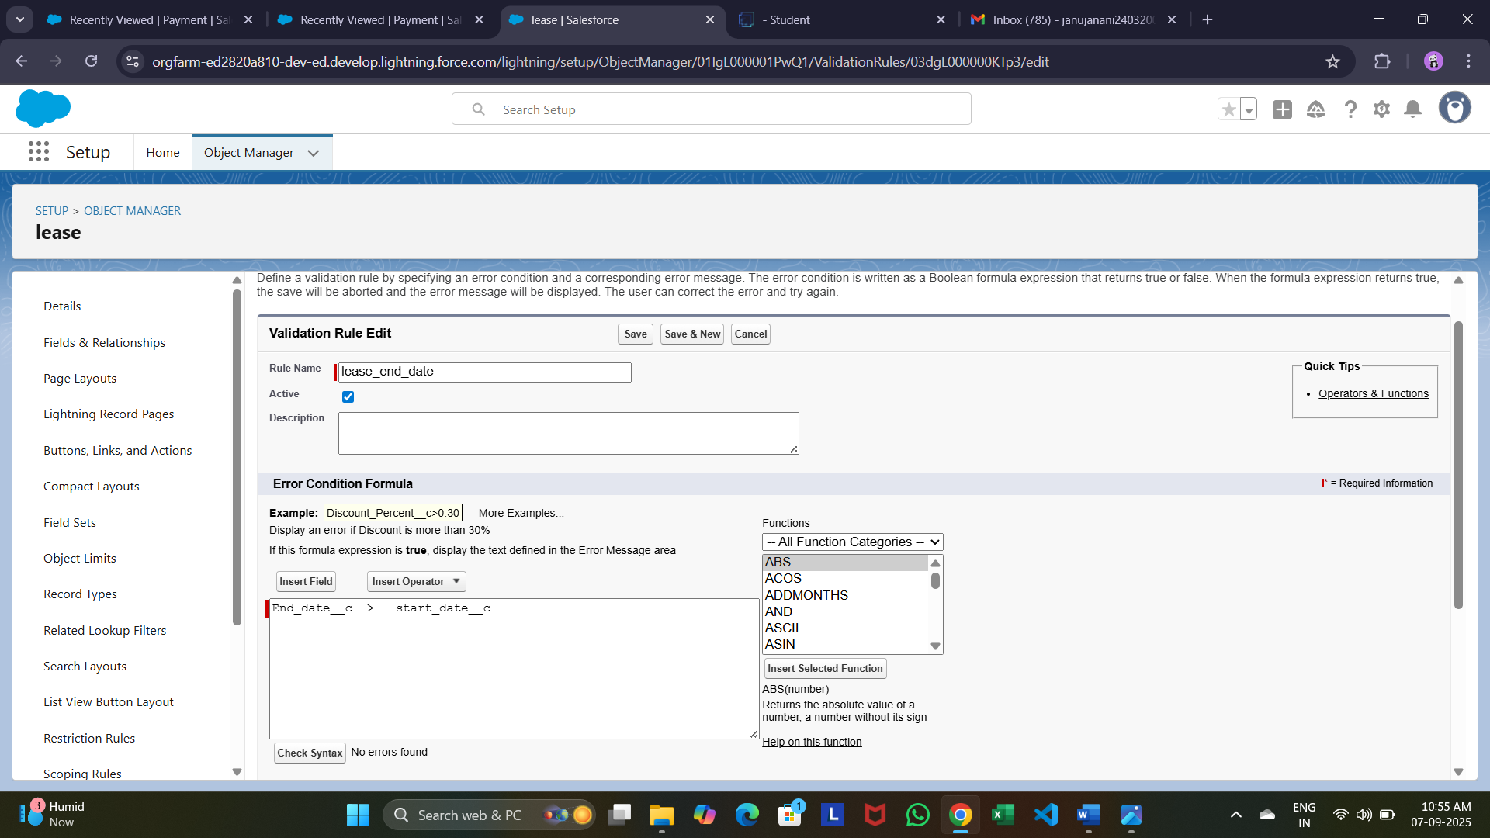

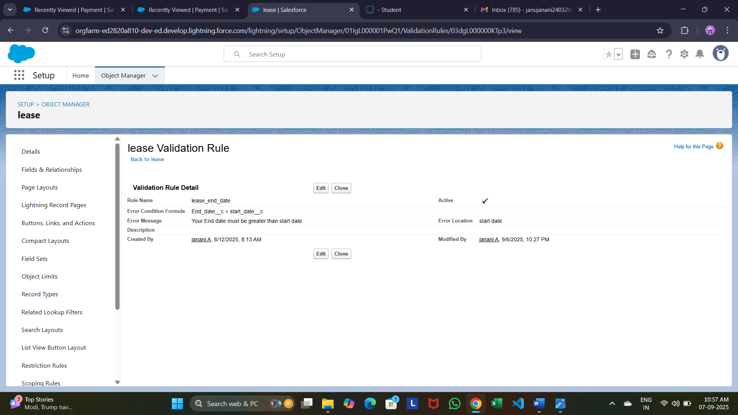

* **Create Email Template**

Tenant leaving

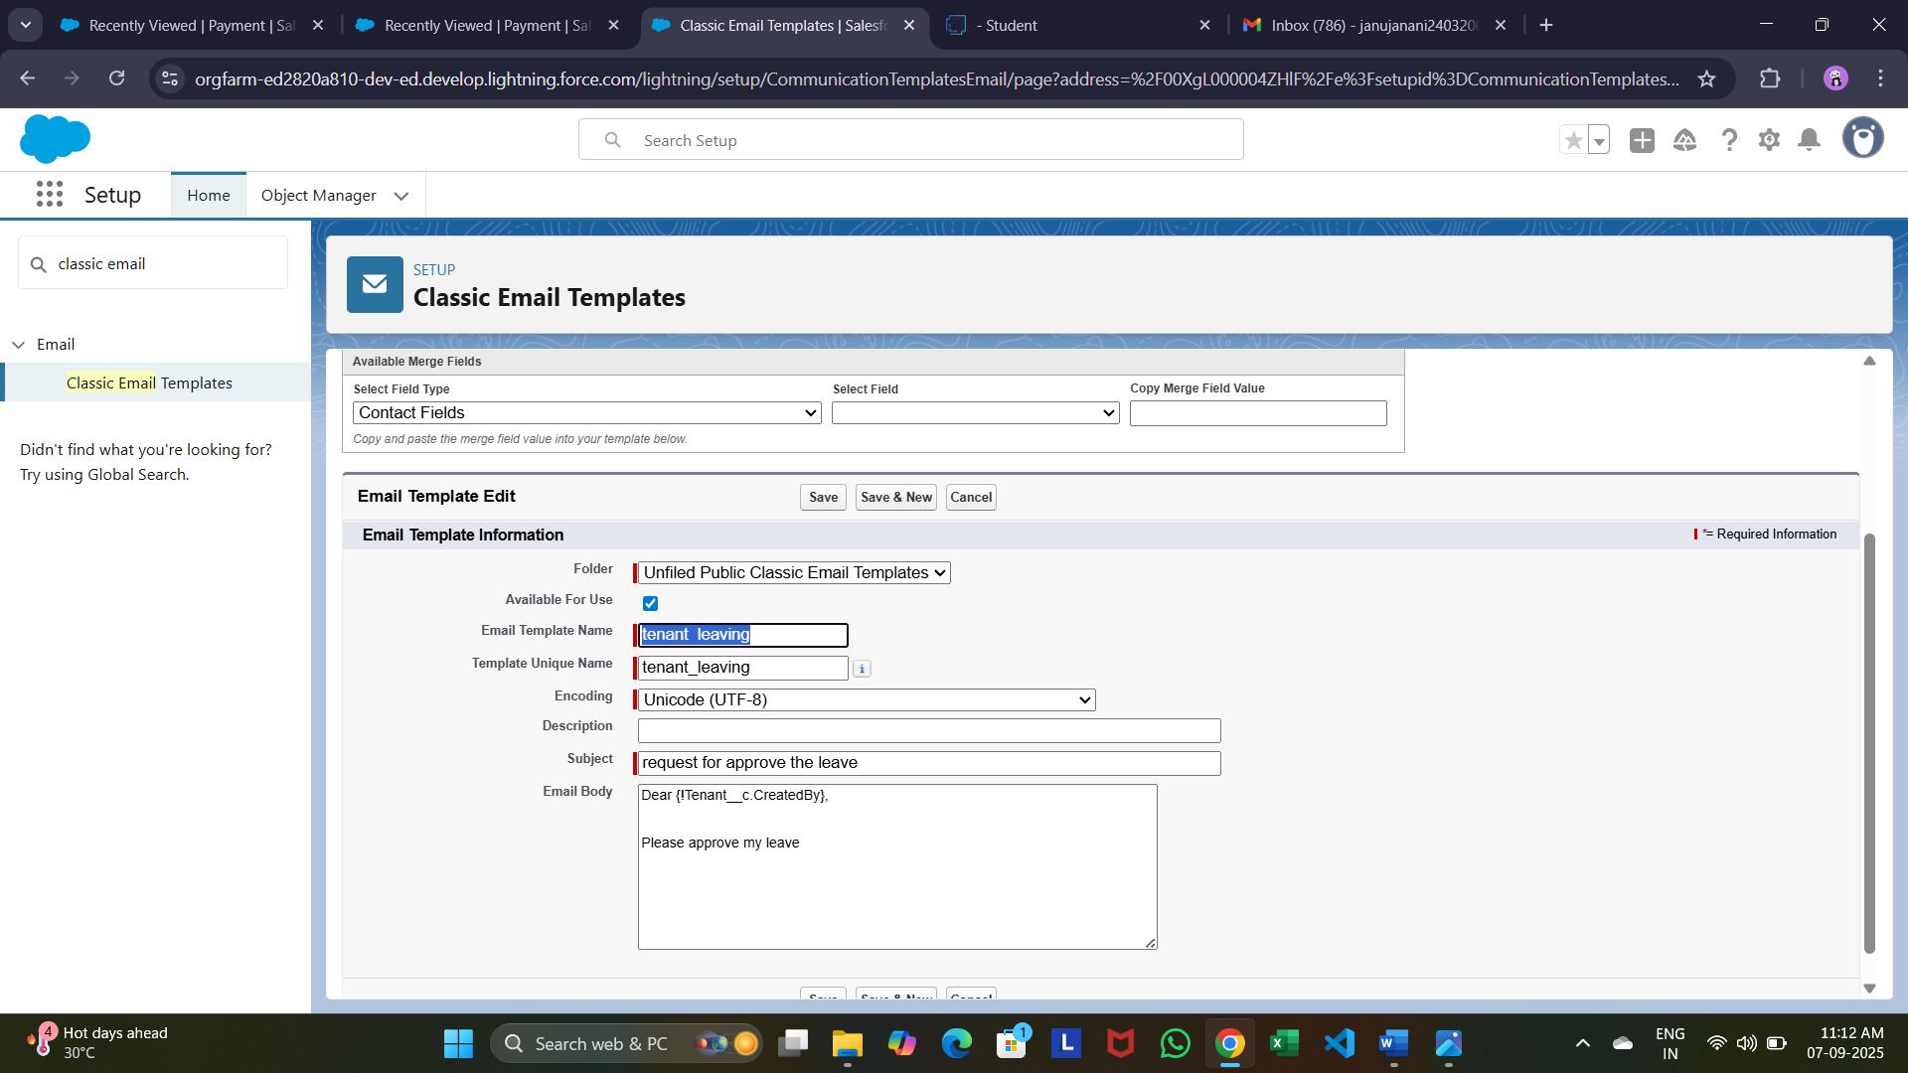

Leave approved

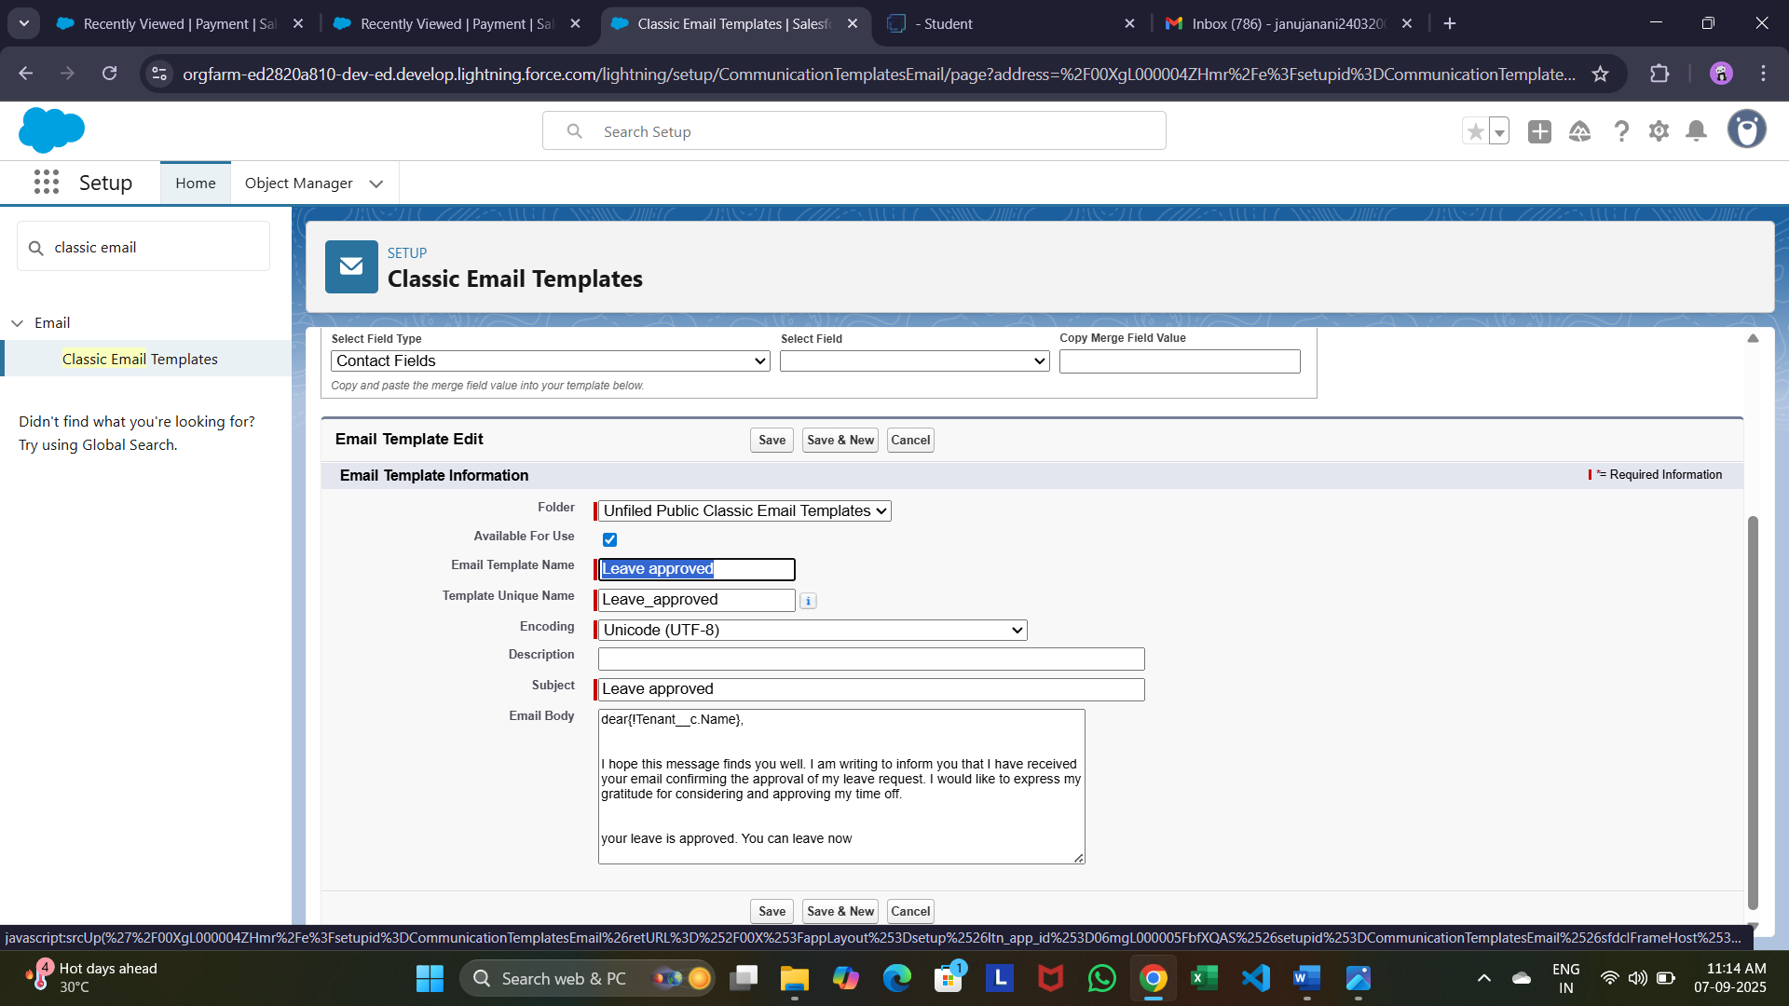

Leave rejected

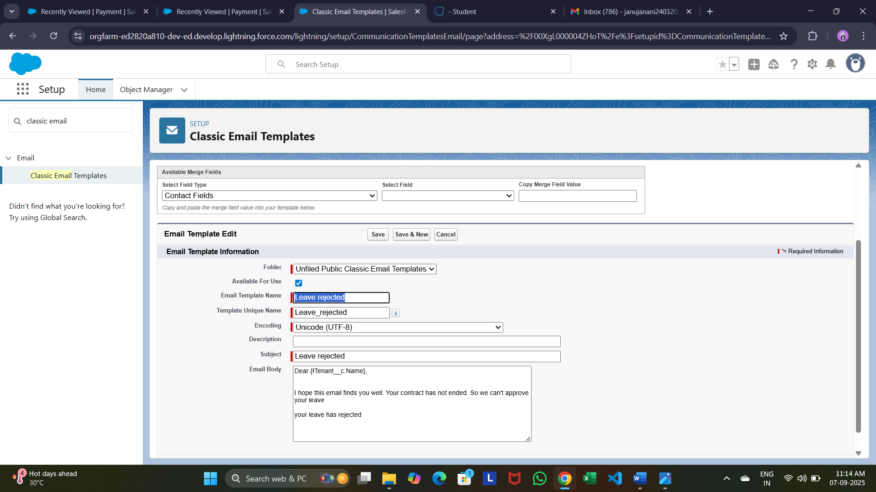

Tenant email

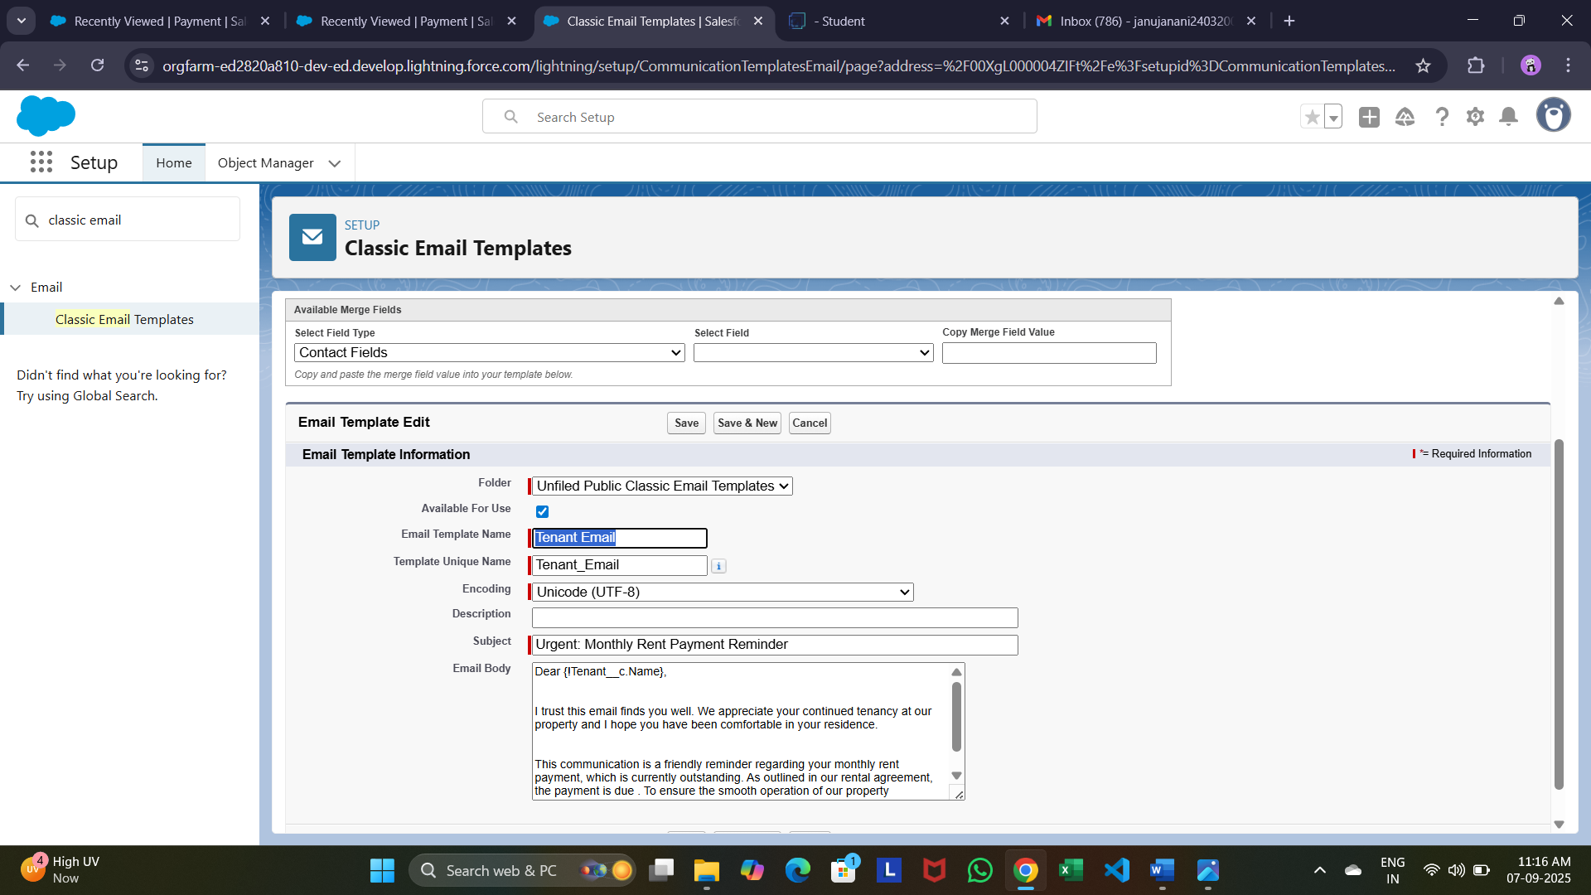

Tenant payment

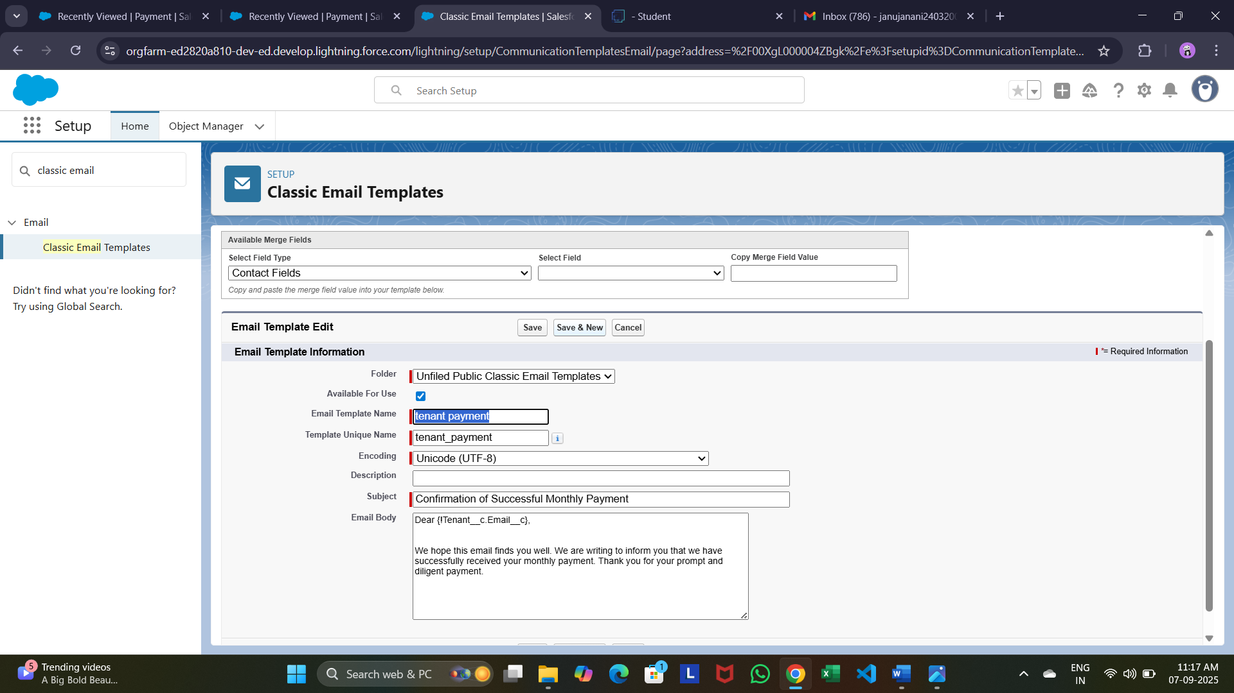

* **Create Approval Process For check for vacant**

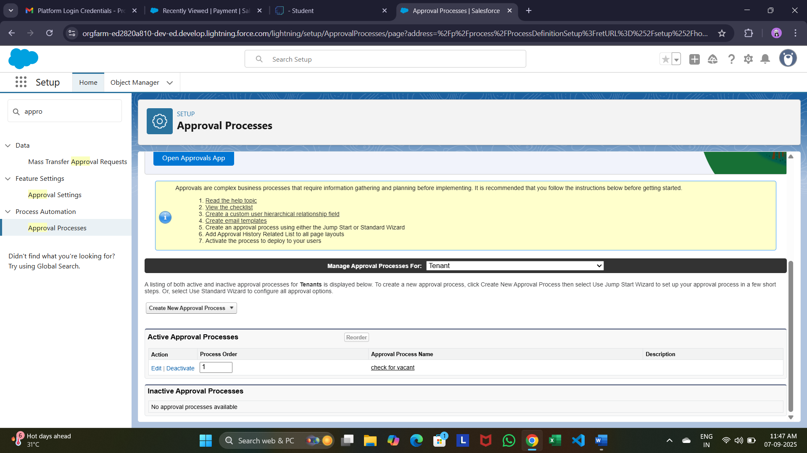

Initial Submission Action:

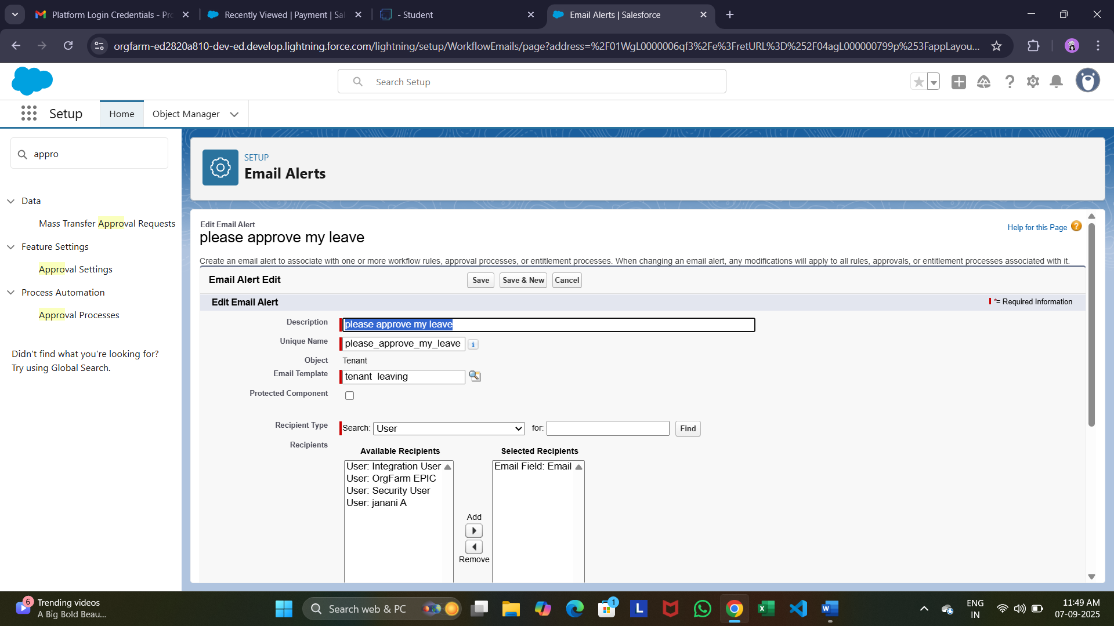

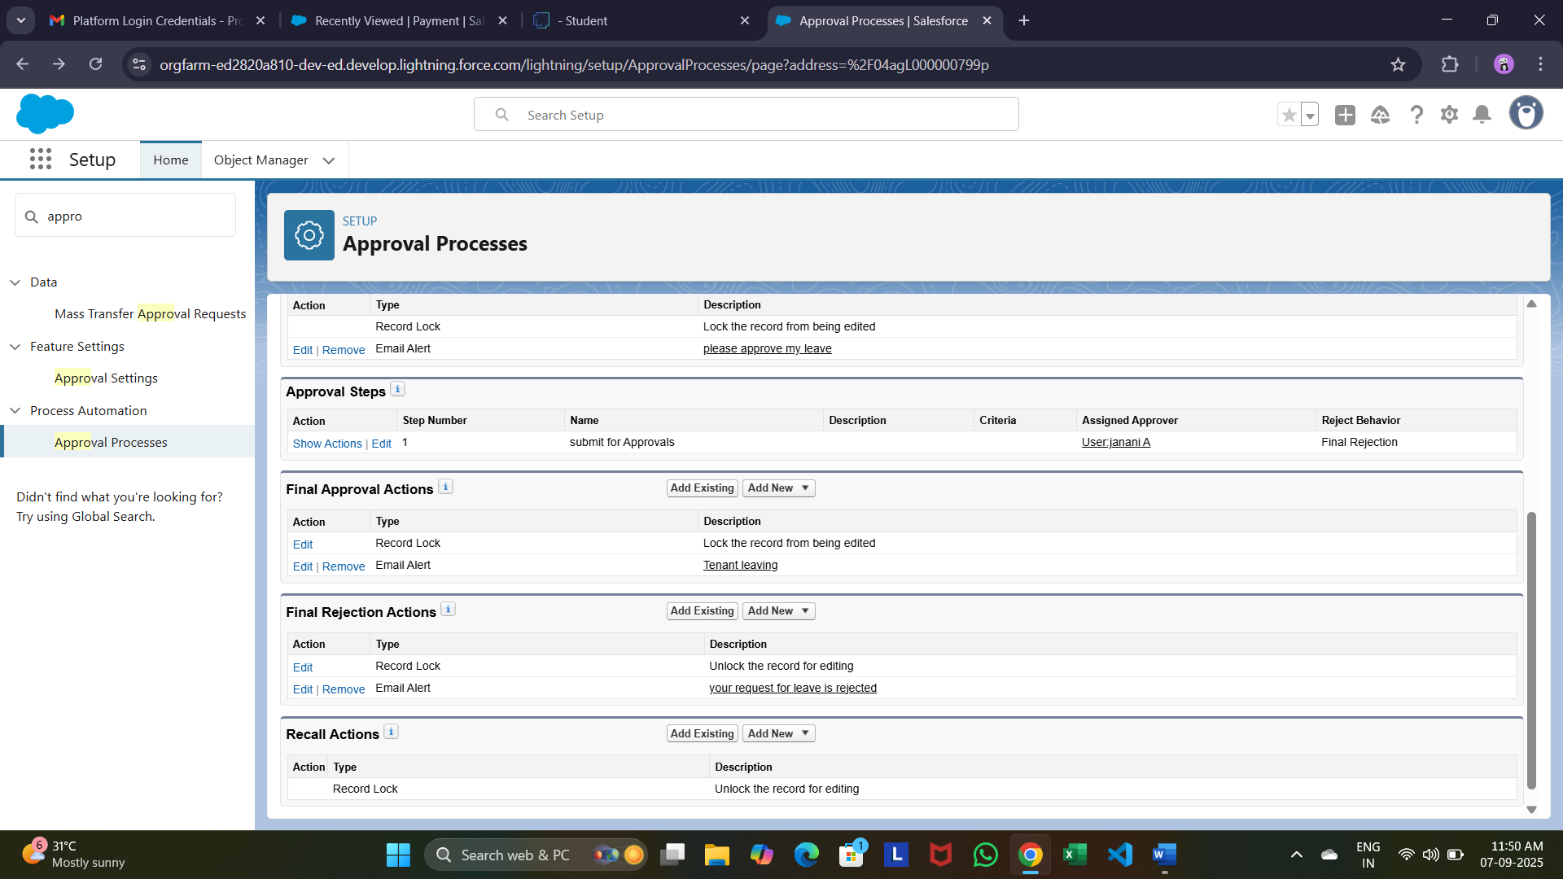

Apex Tigger

Create an apex trigger:

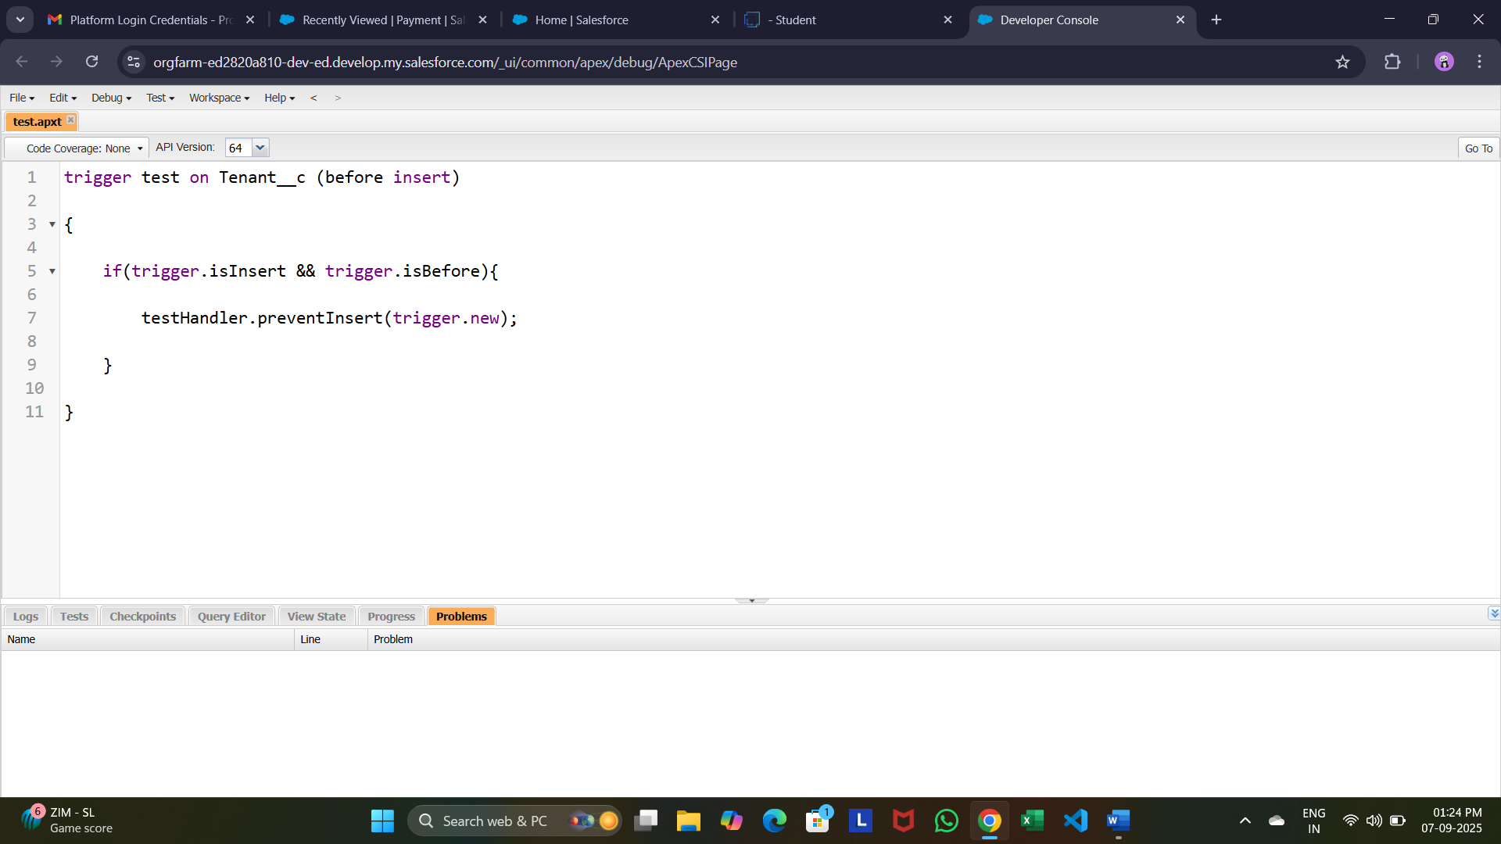

**Create an Apex Handler class**

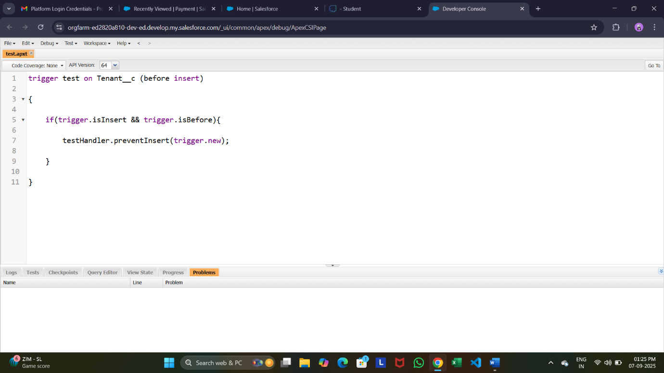

Testing The Trigger:

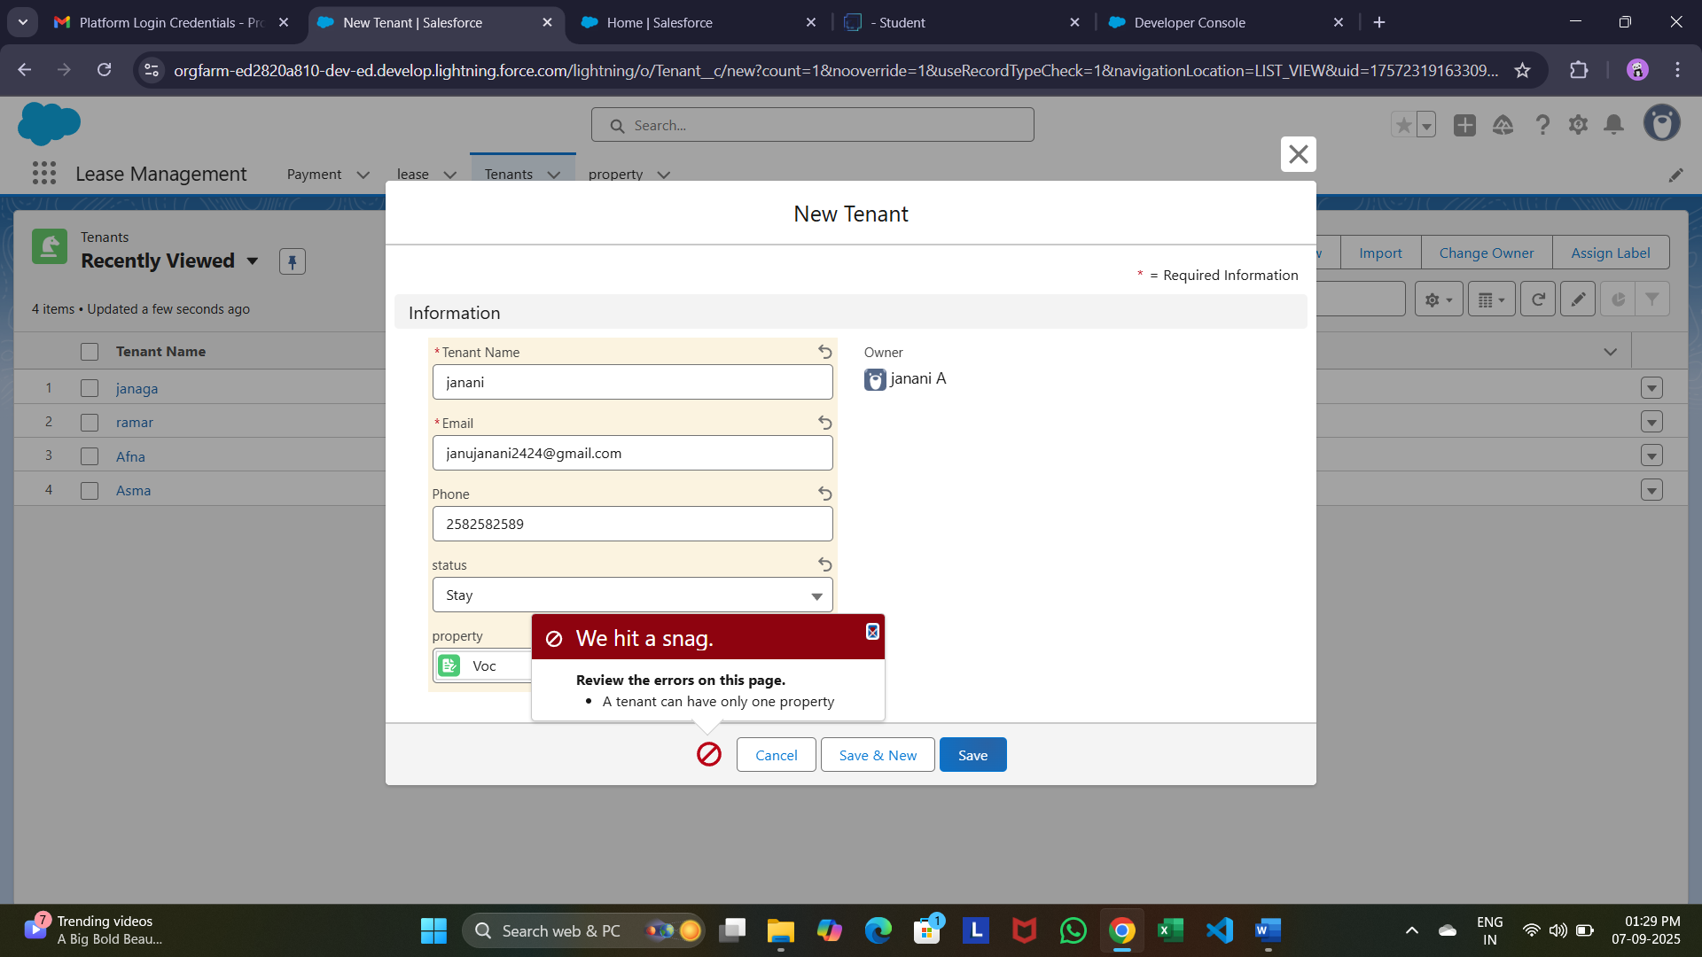

**Create Flow for monthly payment**

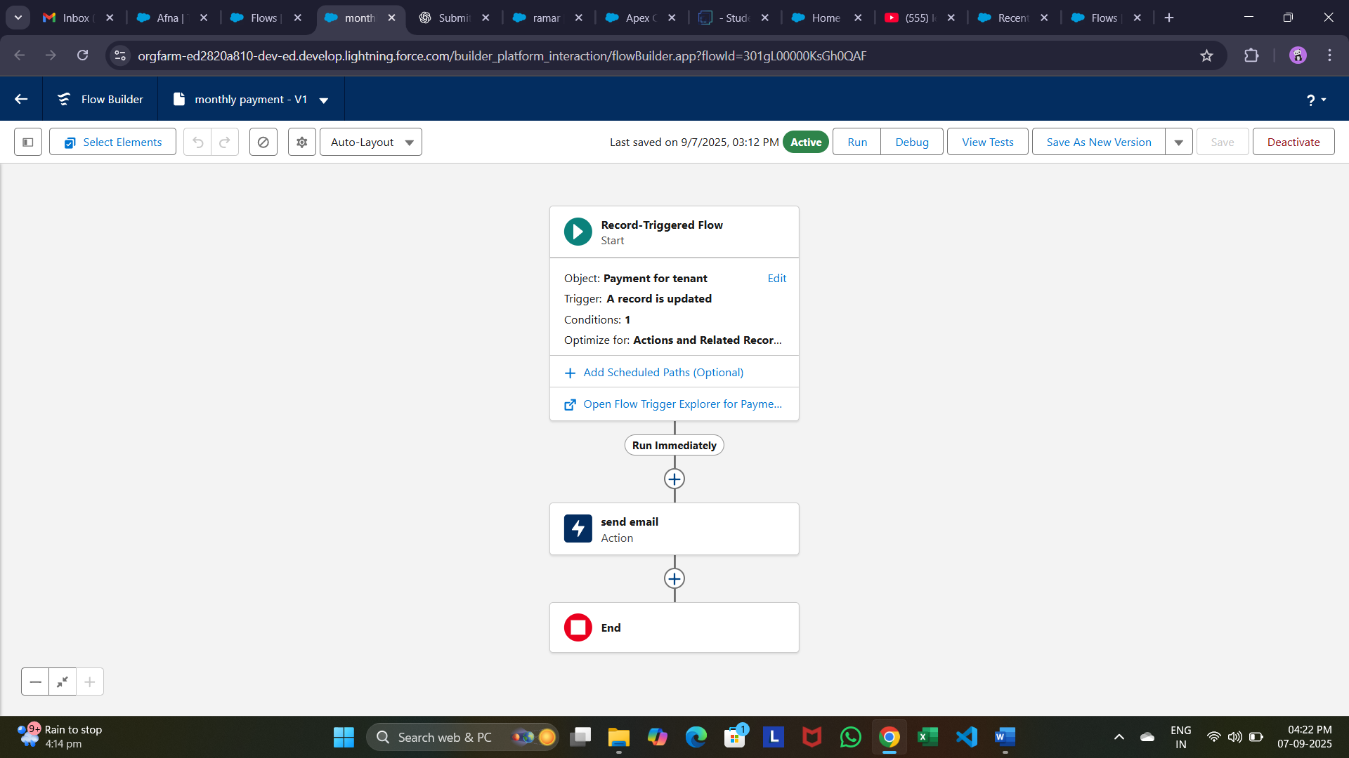

**Schedule class**

**Create an Apex Class:**

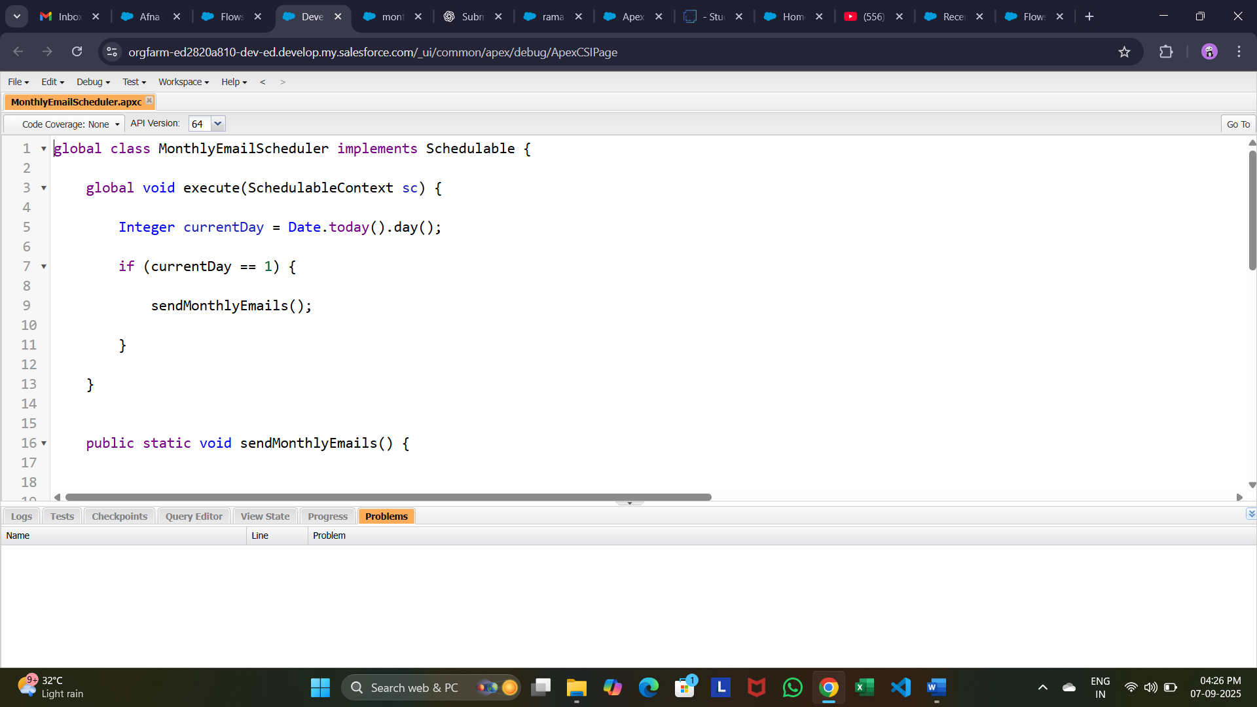

**Schedule Apex class**

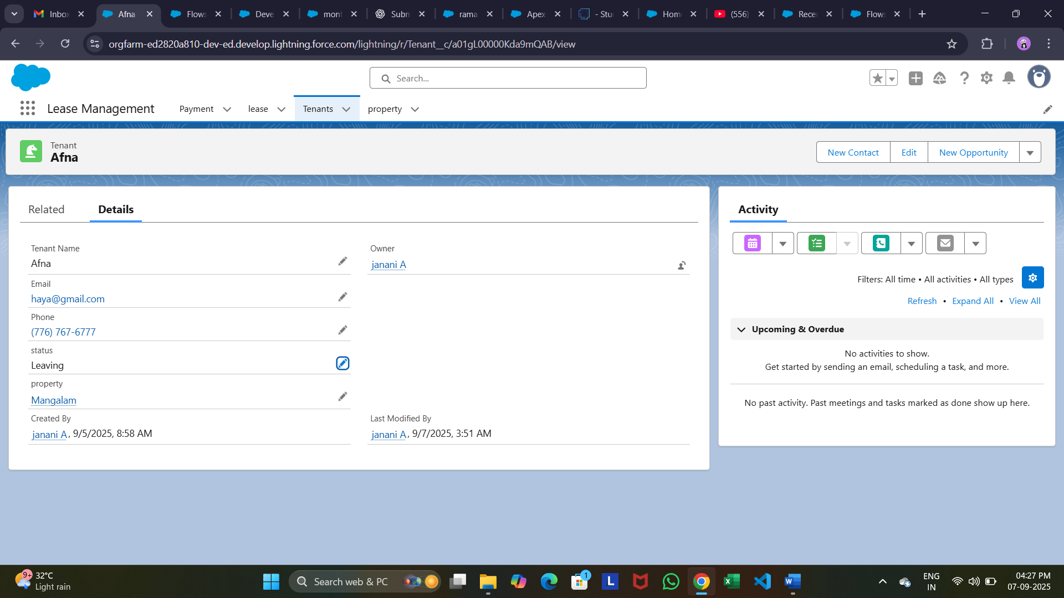

CONCLUSION:

The Lease Management System Successfully streamlines the operations of leasing through a structured, automated salesforce application. It improves efficiently, communication, and data accuracy for both admins and tenants.